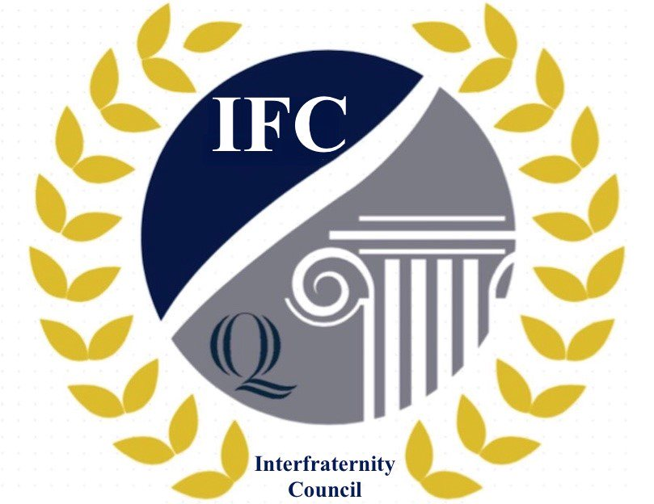

Fall 2020 Fraternity Recruitment

Virtual Planning Guide

The following is a list of events that chapters may want to plan should they need to move recruitment to a virtual format. These are only suggested events brainstormed by IFC; chapters are not limited to these events and are encouraged to be as creative as possible when planning potential virtual recruitment events.

Virtual Recruitment Event Suggestions:
Meet the Brothers Substitute Events:
- Convert the Meet the Brothers event directly into a format that fits into Zoom
- Small break out rooms within a Zoom call that have a few brothers in each room
- Have PNM and a brother play a game online while they chat in a breakout room
- Presentation about the fraternity followed with breakout rooms for PNMs to meet and talk with brothers
- Icebreakers/teambuilders (Google them – there are thousands!)
- Bring your favorite ____ for show and tell (____ meaning Tik Tok video, prized possession you have with you at school, talent, etc.)
Athletic Events Substitute Events:
- Online video game tournament (consider it may require PNMs to have some equipment)
- Online games where you make teams made of PNMs and brothers (see – Virtual Event Platforms below). Game ideas:
  - The game Skategories is easy to convert to online if you type the lists in advance to show on the screen.
  - Charades
  - Pictionary
  - Would You Rather?
  - Two Truths & a Lie
- Watch sport highlights or game, have breakout rooms for PNM’s to talk with brothers
- Trivia or jeopardy games, put PNMs and brothers on teams together in small groups
- Card game or online card game such as UNO or Cards Against Humanity
- Build-it challenge – give them something to build/make out of any materials available in their room/house
Ideas for Virtual Interviews:
- Host over Zoom or another online platform
- Keep brother-to-PNM ratio small so as not to intimidate PNMS; If necessary, record interviews for brothers who can’t attend to watch later
- Make sure to introduce yourself at the beginning and ask them to do the same before jumping into questions; have small talk to make the PNM comfortable
- After you’ve asked the fraternity’s questions, invite PNMs to ask you questions
- Finish the interview with what they can expect to happen next and how to get in touch with you if they have questions
Formal Dinner Substitute Events:
- If you can have in-person gatherings, make them smaller to meet social distancing guidelines; mix small groups of brothers with PNMs for dinner.
- If you have to have very small groups, assign a specific brother to one specific PNM 1:1, 2:1, or 2:2 and they go to dinner (because everyone has to eat dinner). This was you can have a formal meal without having to have an event.
- If there is a speech component to formal dinner, do that at a separate time over Zoom and record for PNMs who might be in class, etc.
- If allowed to have some in-person, could have outside dinner/BBQ where PNMs can hang out and still get some feeling of a dinner with brothers.
Other Virtual Event Suggestions:
- Speaker night – seniors, alumni, regional officer, advisor, anyone in your chapter who is a great orator – live via Zoom with a recording for those who can’t attend
- Philanthropy spotlight – invite someone from your partner philanthropic organization to give a short presentation about their org/cause, pair with a speech from the philanthropy chair about what events you put on throughout the year to raise money, if you do any service for them, etc. Then break PNMs and brothers into breakout rooms to talk more in depth about the info. Host live via Zoom with a recording for those who can’t attend
- Q&A session with chapter leadership/recruitment chairs/newest pledge class, etc. live via Zoom with a recording for those who can’t attend.
- Anything you are doing already as virtual brotherhood events – invite PNMs so they can see what being part of the fraternity is like!
  - Article: “44 Ways to Foster Brotherhood and Sisterhood Virtually” https://nicfraternity.org/44-ways-to-foster-brotherhood-sisterhood-virtually/
Virtual Event Game Platforms:
- Remo
- House Party
- JackBox
- Twitch
- Game streaming on Discord
Virtual Voting:
- Use Zoom to host virtual voting meeting.
- Adapt inter/national voting practices to virtual if possible, consult your HQ if not possible or to find out if there are special instructions for voting due to virtual recruitment/voting.
- If you don’t have inter/national voting practices and HQ has no suggestions, list all PNMs, conduct a pre-vote on each of them, and decide on a threshold (% of yes votes) above which those PNMs get a bid, automatically. For any PNMs below the threshold, have a conversation about them (pro-con-pro related to membership criteria and fraternity values, as an example), then revote on their membership to determine bid or no bid.
- Utilize poll feature or a separate OneDrive form for voting.
- Use Raise Hand feature and appoint a moderator to call on members before speaking to minimize having members talking over one another.

Possible Virtual Recruitment Schedules:
- Keep current recruitment schedule as planned and transition each event to a virtual platform using suggestions above or other events.
- Scrap current plan entirely and plan a new, fully virtual recruitment from scratch. If you choose this, we encourage you to keep your Meet the Brothers event (or whatever your first event becomes) on the same day and time so as not to overlap with other chapters’ events.
- Develop a hybrid plan of virtual and in-person events that meets social distancing and other guidelines.

IFC Event Information and Guidelines:
- Meet the Greeks will not take place on August 23, 2020 as planned because all students will not be back until September 7, 2020.
- IFC info sessions for PNMs will be held on the following days and times, whether they are in-person or virtual:
Date & Day | Start Time | End Time | Intended Location
8/27/20 Thurs | 9:15 PM | 10:15 PM | CCE 101 (MTA)
8/30/20 Sun | 3:00 PM | 4:00 PM | CCE 101 (MTA)
8/31/2020 Mon | 9:15 PM | 10:15 PM | CCE 101 (MTA)
- The first day that fraternities may hold recruitment events is Tuesday, September 1, 2020.
- Chapters must check PNM grades prior to giving out bids. Grades can be found on the registration form provided by IFC. Fraternities may not give bids to men who are academically ineligible (meaning they have below a 2.5 GPA) but are free to enforce their own GPA requirements if they are higher than 2.5.
- Bids may not be given out until the end of the IFC grace period. The first day on which fraternities may extend bids for fall 2020 is Thursday, September 10, 2020.
- Please refer to the full copy of recruitment rules which can be found in the IFC Bylaws on their Do You QU page for more information.

Other Resources:
- The NIC has various resources for council and chapters to plan for virtual recruitment and other events in the fall - https://nicfraternity.org/
- Campuspeak has hosted webinars on recruitment during the pandemic; you can find the recordings on their website - https://campuspeak.com/
- PhiredUp! is an industry leader in recruitment prep and is always coming up with new content - https://www.phiredup.com/
- LaunchPoint video – https://vimeo.com/421129126 – We agree with the quote, “Good enough is good enough.”

