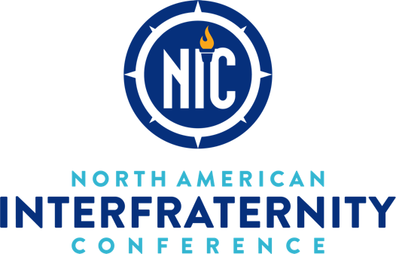

PROGRAMMING CATALOG

FOR DIAMOND-LEVEL CAMPUSES

To achieve the [Vision for Fraternity Communities](http://vfc.nicindy.org/) (VFC)—Engendering Trust and Confidence in the Fraternity Experience, the NIC has partnered with content experts to provide programming and interventions in key areas. Research shows the need and benefit of focusing programming on these critical topics to cultivate fraternity men and address alcohol abuse.

* **Rites of Passage Programming**— “Joining a fraternity is often a charged and confusing life stage, not only for the new members, but also for those who live and work with them,” as one of the NIC’s programming partners puts it. The NIC has partnered with experts to help men explore positive, meaningful rites of passage in their fraternity experience.
* **Sexual Misconduct Prevention Programming**— The NIC has partnered with renowned experts on sexual health, sexual misconduct, and bystander intervention to provide resources to help fraternity men and their campus peers be leaders in eliminating sexual assault.
* **Bystander Intervention Programming**— Helping students feel and be prepared to intervene when injustice or assault is happening is critical for creating safer and healthier communities. The NIC has partnered with experts in bystander intervention to provide programs for fraternity and sorority members.
* **Social Norming Interventions**— The NIC’s Campus Support Model includes services designed to assess social norms, debunk local myths and misperceptions, and establish campus-specific strategies to tackle unhealthy behaviors.

Review the catalog below see the programs offered. For administrators and Council officers at Diamond-level campuses in the [Campus Support Model](https://www.nicindy.org/ifc/campus-support/), start the booking process by contacting [your Campus Support representative](https://www.nicindy.org/connect/staff/).

**Each Diamond-level campus has 15 programming credits per year through their Campus Support package. Programs vary in credit “cost.”**

**The Community Voice An Introduction to the Realities of Bystander Behavior**

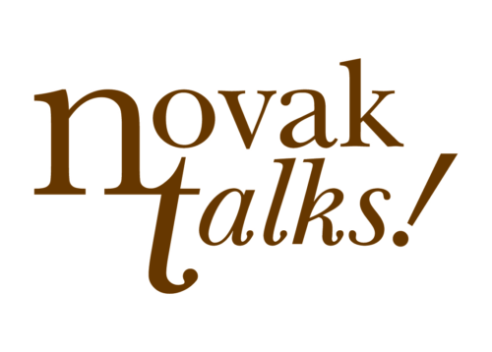

*Presenting Partner: NovakTalks*

**Cost: 7.5 CREDITS**

**Category: Bystander Intervention**

**Program Description:** Challenge students to find their voice and not stand by when the values of their organization are not reflected in actions or vxoices of individuals, chapters or campus communities. Using the principles of Bystander Intervention as a foundation the facilitator empowers participants to find their voice by accepting their responsibility to act as positive members of their organization, community or chapter. This is a critical conversation to focus on creating a community of care.

**Goals:** This dynamic program will empower participants to:

* Articulate the importance of moving through all the stages of intervention in order to bring about change, focusing on the final two stages of Bystander Intervention: Stage 3–Feel Responsible for Solving the Problem & Stage 4–Possessing the Necessary Skills to Act.
* Challenge themselves and their community to feel responsible for acting when behaviors or incidents are not aligned with values.
* Learn about successful intervention strategies that will provide opportunities to respectfully and effectively intervene and provide the opportunity to de-escalate challenging situations.

Time: 1.5 to 2 hours

Intended Audience: Chapter leaders, members and new members

Partner Bio: Founded in 2009, NovakTalks provides consulting and advocacy for Campus Safety, Hazing Prevention, Student Risk Management and Student Organization Development. We have a dynamic team of facilitators all trained in the Novak education model. Services can be tailored to meet the needs of your campus/community, organization/chapter or staff.

More Information: Download a [one-pager](https://www.nicindy.org/wp-content/uploads/2017/08/Community-Voice_NovakTalks.pdf) about this program.

Booking Information: [Amy@NovakTalks.com](mailto:Amy@NovakTalks.com)

**Website:** <http://www.novaktalks.com/campus-and-community>

Complex Problems & Simple Solutions



Presenter: Steve Whitby

Presenting Partner: The Catalyst Agency

Cost: 7.5 CREDITS

Category: Social Norming

**Program Description:** In this training, participants will engage in a community conversation around problems in the areas they wish to focus on. They will achieve a better understanding around the framework of stages of change, harm reduction and brain development. Information can also be tailored to include university policy and how the information compares and contrasts. Ultimately, participants will learn how to create safe events in compliance with the policy through event planning and prevention resources.

Time: 75-90 minutes

**Intended Audience:** Fraternity and sorority leaders (groups under 100).

**Presenter Bio:** Steve Whitby is a storyteller who puts his twenty years of on-the-ground leadership development work into action by challenging people to make real changes by better understanding their own role in the story. As one of the authors of the most widely used risk management prevention curriculum used by fraternities, sororities, and college campuses, Steve has put his passion for creating change into action. He is an intentional speaker, conveying critical lessons about leadership and human potential through stories of normal people facing extraordinary opportunities.

**More Information:** Download a [one-pager](https://www.nicindy.org/wp-content/uploads/2017/08/Complex-Problems_Whitby_Catalyst.pdf) about this program.

**Booking Information:** [info@thecatalystagency.us](mailto:info@thecatalystagency.us) or 704-359-7941

**Website:**<http://thecatalystagency.us/about/steve-whitby/>

Creating Resilient Organizations  
*Presenting Partner: Growth Guiders*

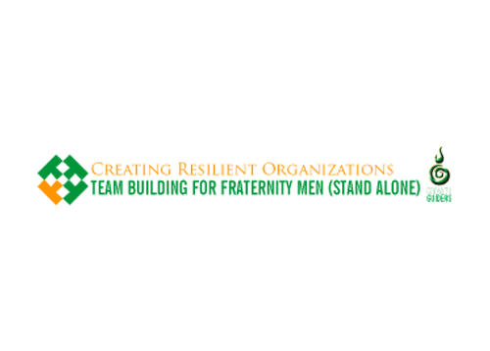

Cost: 5 CREDITS

Category: Social Norming

Program Description: This workshop is designed to increase students’ knowledge and understanding of leadership and team development through a combination of information sessions and active participation in cooperative, challenge activities. Introductory activities help students to get to know each other and begin to work together to solve problems and think “out of the box.” Topics to be presented and discussed include the communication process, leadership models and styles, stages of team development, ethics, diversity, and visionary or principle-centered and creative leadership. The course will culminate in the development of personal mission statements and their presentation, along with short group presentations of key learnings.

Goals:

* To increase knowledge, understanding, and skills related to leadership involved in team building.
* To increase knowledge and understanding of team development.
* To become a more effective team member in working with people of diverse backgrounds, cultures, philosophies, approaches, strengths, and limitations.

**Time:** 2.5 hours

**Intended Audience:** IFC Leadership, Chapter Leadership Teams, Fraternity Educators, Full Chapter Membership

**Partner Bio:** Growth Guiders believes in delivering inspirational programs ranging from small group facilitation to large group keynotes to academic presentations at professional conferences. Growth Guiders takes extra steps to ensure that our learning experiences not only engage students, but lead them on a path to discovery and extend learning into action.

**More Information:** Download a [one-pager](https://www.nicindy.org/wp-content/uploads/2017/08/Creating-Resilient-Orgs_Growth-Guiders.pdf) about this program.

**Booking Information:** [John@growthguiders.com](mailto:John@growthguiders.com)

**Website:** [www.GrowthGuiders.com](http://www.growthguiders.com/)

The Effect of Social Norming on College Campuses

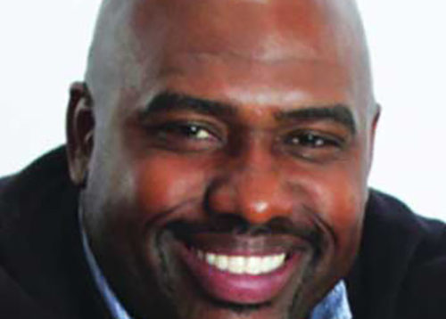

Presenter: Dr. T. Leon Williams

Presenting Partner: The Catalyst Agency

Cost: 7.5 CREDITS

Category: Social Norming

**Program Description:** One of the unique perspectives on every college campus is the bystander. The bystander gets a front row seat to good and bad times, fun and danger, risk taking and poor decision making, close calls and regrets. The bystander spends meaningful hours observing social behaviors that trigger unusual or habitual behaviors. By the end of the night, the bystander has developed a biased perception of responsible social living. The bystander plays a very important role in the acceptance and rejection of social norms on college campuses. This program will help students accurately and respectfully regard their peers as responsible community members.

**Goals:**Student will be able to:

1. Gain an understanding of social norms
2. Understand how bias influence decision-making
3. Develop intervention strategies to correct misperceptions
4. Identify healthier norms

**Time:** 75-90 minutes

**Intended Audience:**Fraternity men and chapters

**Presenter Bio:**Dr. T. Leon Williams has worked at various colleges and universities in multicultural affairs and athletics, and he has a special passion for diversity education. His topics are serious but his professional experience has allowed him to reach students using humor, personal stories, monologues and music. He invites students to examine their thoughts, perceptions and worldview. He is a frequent presenter for orientation, fraternity and sorority new member training, residence life training, affinity group empowerment, and community development.

**More Information:** Download a [one-pager](https://www.nicindy.org/wp-content/uploads/2017/08/Effect-of-Social-Norming_Williams_Catalyst.pdf) about this program.

**Booking Information:**[info@thecatalystagency.us](mailto:info@thecatalystagency.us) or 704-359-7941

**Website:** <http://www.leoncharacteredu.com/>

It’s Everybody’s Job: Building Safer Communities

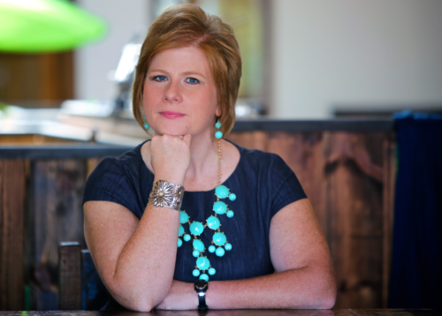

Presenter: Suzette Walden Cole

Presenting Partner: CAMPUSPEAK

Cost: 7.5 CREDITS

Category: Sexual Misconduct Prevention

**Program Description:** Many students cannot clearly recognize the signs of potential risk in some situations, leading to them not realizing the risk at all or feeling too insecure to step in. In this keynote, Suzette offers students the training to confidently step in. She teaches the skills they need to be proactive, aware community members to help stop sexual assault and misconduct.

**Goals:** As a result of attending this program, students will learn:

* The history of alcohol and sexual assault/misconduct on college campuses.
* How to define and understand how to gain and secure consent.
* How to recognize reasons why individuals often do not intervene.
* How to overcome those factors, and techniques for safeguarding events (both unofficial and official).
* The skills to assess situations, determine a course of action, and step-in to ensure the safety and security of their community.

**Facilitator Bio:** Originally from Atlanta, Georgia, Suzette Walden Cole received her Bachelor of Arts from Mercer University in Macon, Georgia and her Master of Education from the University of South Carolina in Columbia, South Carolina. Currently, she is a doctoral candidate in education administration and foundations at Illinois State University, studying the factors that contribute to the development of culture in student groups, student organization conduct and accountability processes and effective strategies for cultivating change within student groups.

**More Information:** Download a [one-pager](https://www.nicindy.org/wp-content/uploads/2017/08/Its-Everybodys-Job_Cole_Campuspeak.pdf) about this program.

**Booking Information:** (844) 745-8570 or [info@campuspeak.com](mailto:info@campuspeak.com)

**Website:**<http://www.campuspeak.com/walden-cole>

Men Coming of Age in Fraternity

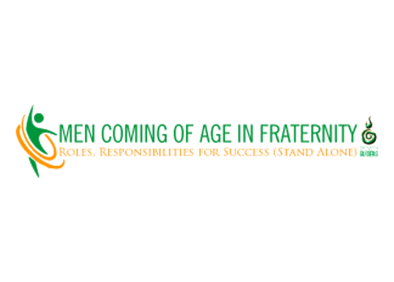

Presenting Partners: Growth Guiders

Cost: 5 CREDITS

Category: Social Norming

**Program Description:** Joining a fraternity is often a charged and confusing life stage, not only for the new members themselves, but also for those who live and work with them. A common assumption today holds that it is inevitably a time of anti-social behaviors, like rebellion, withdrawal, excess, and apathy. Not true! In fact, being a new member is a critical in-between time in which we can begin asking the deeply personal questions of identity and purpose that will make us true adults: creative, generative, ready to shepherd coming generations into a vibrant fraternity experience. It is an essential life stage, full of possibility for individual lives as well as the future of our planet. To enable a successful navigation of personal growth, young people need adults who understand the unique features of this life stage. They need mentors who know how to mark transitions in ways meaningful and relevant in the lives of young people. Most of all, they need adults who have been initiated themselves.

**Goals:**

* Identify the stakeholders involved in the New Member’s introduction to the chapter.
* Develop a deeper understanding of our own transitions into adulthood and gain practical skills for the initiation and mentorship of new members.
* Improve practical skills related to effective and positive engagement and support of New Members that meet the needs of the chapter and the individuals.

**Time:** 2.5 hours

**Intended Audience:** IFC Leadership, Chapter Leadership Teams, Fraternity Educators, Full Chapter Membership

**Partner Bio:** Growth Guiders believes in delivering inspirational programs ranging from small group facilitation to large group keynotes to academic presentations at professional conferences. Growth Guiders takes extra steps to ensure that our learning experiences not only engage students, but lead them on a path to discovery and extend learning into action.

**More Information:** Download a [one-pager](https://www.nicindy.org/wp-content/uploads/2017/08/Men-Coming-of-Age_Growth-Guiders.pdf) about this program.

**Booking Information:** [John@growthguiders.com](mailto:John@growthguiders.com)

**Website:** [www.GrowthGuiders.com](http://www.growthguiders.com/)

Rape Culture: A Survivor’s Perspective



Presenter: Brittany Piper

Presenting Partner: CAMPUSPEAK

Cost: 7.5 CREDITS

Category: Sexual Misconduct Prevention

Program Description: Brittany Piper shares her story of a vulnerable time in her life when she became a victim of sexual assault. Her personal and moving story, blended with non-judgmental and healthy dialogue about rape, helps students see a clearer picture of the realities of the rape culture in which they live. Brittany reveals how we all participate in rape culture and emphasizes the importance of the role they play that can either perpetuate or end the cycle.

**Time:** 75-90 minutes

**Intended Audience:** Fraternity and sorority leaders (groups under 100).

**Goals:** As a result of attending this program, students will learn:

* The impact that sexual violence can have on an individual
* The importance of reporting sexual assault
* How to address the community’s involvement in rape culture through such concepts as victim-blaming, bystander behavior and rape myths
* How to provide healthy support and compassion to a rape survivor

**Presenter Bio:** Brittany is a rape-survivor, women’s rights scholar and activist who has traversed the globe in the fight against sexual violence and women’s rights. A graduate from the Indiana University School of Journalism, Brittany holds a degree in photojournalism, with a minor in women’s studies. She is a member of the Society of Professional Journalists and the National Association of Professional Women.

**More Information:** Download a [one-pager](https://www.nicindy.org/wp-content/uploads/2017/08/Rape-Culture_Piper_Campuspeak.pdf) about this program.

**Booking Information:** (844) 745-8570 or [info@campuspeak.com](mailto:info@campuspeak.com)

**Website:** <http://www.campuspeak.com/brittany>

Removing Barriers to Action: Bystander Intervention

Presenting Partner: NovakTalks

Cost: 7.5 CREDITS

Category: Bystander Intervention

**Program Description:** It is not enough to tell individuals to not be bystanders. We must create environments that empower individuals to act. This interactive workshop engages participants in an evidenced-based discussion about creating environments in their chapters or community that compels action while providing realistic strategies for empowering all members of the chapter or community to use their voice when peer behaviors are not aligned with acceptable standards of behavior.

**Goals:**This dynamic program will empower participants to:

* Utilize the identified barriers to action to evaluate organization environment in order to identify where barriers can be reduced and people can be empowered to ACT.
* Design organization operations/systems as well as basic informational programs in such a way as to remove barriers to action.
* Create initiatives to communicate what behaviors your organization/ community sees as a problem and wants individuals to take action against.
* Design strategically developed training within their community or chapter to create an environment that empowers individuals to act.

**Time:** 2 hours

**Intended Audience:** Chapter leaders, members, new members. Faculty, staff and volunteers that work with organizations are welcome to join.

**Partner Bio:**Founded in 2009, NovakTalks provides consulting and advocacy for Campus Safety, Hazing Prevention, Student Risk Management and Student Organization Development. We have a dynamic team of facilitators all trained in the Novak education model. Services can be tailored to meet the needs of your campus/community, organization/chapter or staff.

**More Information:** Download a [one-pager](https://www.nicindy.org/wp-content/uploads/2017/08/Removing-Barriers_NovakTalks.pdf) about this program.

**Booking Information:** [Amy@NovakTalks.com](mailto:Amy@NovakTalks.com)

**Website:**<http://www.novaktalks.com/campus-and-community>

RESPONSE ABILITY:



A Call for Courage

Presenter: Mike Dilbeck

Presenting Partner: CAMPUSPEAK

Cost: 7.5 CREDITS

Categories: Bystander Intervention

**Program Description:** When we move past our fears to take action to do what is right on behalf of others and in moments of need, we are truly courageous. RESPONSE ABILITY, is a keynote focused on our role as a bystander in critical situations and the barriers many of us feel when we consider whether or not to intervene. Students from all walks of life will learn how seizing an opportunity to act creates positive change on campus and beyond.

**Goals:** As a result of attending the program, students will:

* Understand the impact of bystander behavior.
* Become reacquainted with personal commitments and actions that make a difference.
* Gain the social awareness and personal power to intervene in problem situations and show courage.

**Time:** 1.5 to 2 hours

**Intended Audience:** Chapter/IFC leaders, members and new members

**Partner Bio:** Mike is a Chicago-based filmmaker, turned advocate. Since 1990, he has created educational projects aimed at empowering young people, including 60 educational film project for Higher Education organizations. Mike now dedicates himself full-time to the RESPONSE ABILITY program. He is a member of the Sigma Nu Fraternity and a member of the National Speakers Association. Mike holds the designation of Certified Speaking Professional, held by less than 12 percent of speakers worldwide.

**More Information:** [www.campuspeak.com/dilbeck](http://www.campuspeak.com/dilbeck)

**Booking Information:** [Request](http://www.campuspeak.com/ask-speaker-2/)

**Website:** [www.campuspeak.com](http://www.campuspeak.com/)

Retaking Our Story: Reframing Sexual Assault Conversation

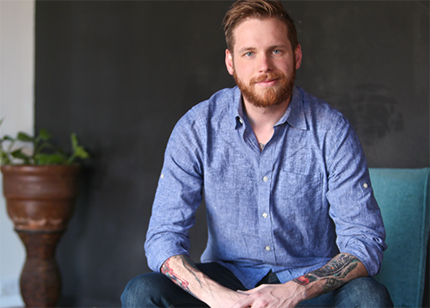

Presenter: Tim Mousseau

Presenting Partner: CAMPUSPEAK

Cost: 7.5 CREDITS

Category: Sexual Misconduct Prevention

**Program Description:** In Retaking Our Story, Tim leads a deep and vulnerable conversation on the difficult topic of sexual assault, drawing from his own experience and interactions with others. Tim helps communities understand the background information needed to facilitate healthy conversations on sexual assault, resources for survivor recovery and how the power of stories can be utilized in prevention. Students leave prepared to create a culture of compassion, while realistically facing an issue prevalent on campuses across the country.

**Goals:** As a result of attending this program, students will learn:

* How to recognize the emotional, physical, and psychological impacts of sexual assault.
* The difference between cultures of shame and cultures of acceptance when creating safe environments for conversation about sexual assault.
* How to empower a supportive campus culture, focused on reducing sexual assault, promoting healthy prevention and effective use of resources.
* How to define the different terms and actions involved with sexual assault, how these can impact an individual and how to be prepared to address these issues within their community.

**Presenter Bio:** Tim received his master’s degree in organizational leadership from Gonzaga in 2013. In the past few years, he has spent his time researching how innovation relates to leadership and the need for service in creativity. In the past, he has worked for his fraternity, Sigma Chi, as well as spending time working with close to 175 campuses through the NIC. Tim spends his spare time as a painter and has personally designed his 20+ tattoos.

**More Information:** Download a [one-pager](https://www.nicindy.org/wp-content/uploads/2017/08/Retaking-Our-Story_Mousseau_Campuspeak.pdf) about this program.

**Booking Information**: (844) 745-8570 or [info@campuspeak.com](mailto:info@campuspeak.com)

**Website:**  <http://www.campuspeak.com/mousseau>

Rites of Passage Retreat: Useful and True Ceremonies



Presenting Partners: Growth Guiders

Cost: 10 CREDITS

Category: Rites of Passage

**Program Description:** In this advanced retreat in ceremonial design and ritual practice, attendees will look more closely at the nature of self-generated ceremonies that honor the healthy maturation of self and other members of their chapter. Drawing upon ideas of the Indigenous peoples, the retreat will bring together the introductory workshops – Useful and True Ceremonies and Ritualism & Sacred Experiences to further develop the competencies associated with leading healthy Rights of Passage for groups. Participants will be invited to design their own self-generated healing ceremony and then we will enact those ceremonies in the presence of fellow attendees. Previous experience with ritual enactment is highly recommended.

**Goals:**

* Identify how to work through a design process for rituals and ceremonies.
* Apply organizational & community values along with Fraternity ethics throughout the design process.
* Present the opportunity for attendees to create a personalized ceremony for working on Rights of Passage at home in their own chapters.

**Time:** 2-day retreat (12 hours)

**Intended Audience:** IFC Leadership, Chapter Leadership Teams, Fraternity Educators & Ritualists, Chapter Advisors

**Partner Bio:**Growth Guiders believes in delivering inspirational programs ranging from small group facilitation to large group keynotes to academic presentations at professional conferences. Growth Guiders takes extra steps to ensure that our learning experiences not only engage students, but lead them on a path to discovery and extend learning into action.

**More Information:** Download a [one-pager](https://www.nicindy.org/wp-content/uploads/2017/08/Appropriate-Ceremonies_Growth-GUiders.pdf) about this program.

**Booking Information:** [John@growthguiders.com](mailto:John@growthguiders.com)

**Website:**[www.GrowthGuiders.com](http://www.growthguiders.com/)

Sacred Experiences: The Design of Ceremonies and Rites of Passage



Presenting Partner: Growth Guiders

Cost: 5 CREDITS

Category: Rites of Passage

**Program Description:** This workshop guides attendees on the journey of transforming a space into a sacred place. We can all intentionally create areas to reflect, recharge, celebrate, or to promote any soulful growth a chapter can imagine. Sacred space can be created in any environment, individually or in a collaborative group. In this hands-on workshop, attendees collaborate together on a design for a Rite of Passage. They begin by preparing the area and one another through a process that can carry on throughout all rituals and ceremonies that chapters practice. The process of design will encourage everyone to engage in collaborative group work and observing the space being designed by each other.

**Goals:**

* Identify how to work through a design process for rituals and ceremonies.
* Apply organizational & community values along with Fraternity ethics throughout the design process.
* Present the opportunity for attendees to create a personalized ceremony for working on Rights of Passage at home in their own chapters.

**Time:** 2.5 hours

**Intended Audience:** IFC Leadership, Chapter Leadership Teams, Fraternity Educators & Ritualists, Chapter Advisors

**Partner Bio:**Growth Guiders believes in delivering inspirational programs ranging from small group facilitation to large group keynotes to academic presentations at professional conferences. Growth Guiders takes extra steps to ensure that our learning experiences not only engage students, but lead them on a path to discovery and extend learning into action.

**More Information:** Download a [one-pager](https://www.nicindy.org/wp-content/uploads/2017/08/Sacred-Experiences_Growth-Guiders.pdf) about this program.

**Booking Information:** [John@growthguiders.com](mailto:John@growthguiders.com)

**Website:**[www.GrowthGuiders.com](http://www.growthguiders.com/)

SPEAKUP: CAMPUSPEAK Online Education

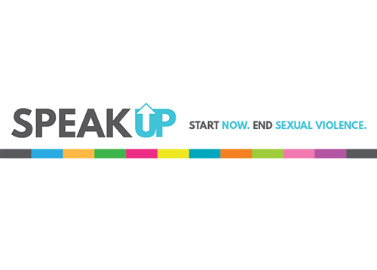

Presenting Partner: CAMPUSPEAK

Category: Sexual Misconduct Prevention

**Program Description:** SPEAKUP is an online educational training program that uses real stories, told by survivors of sexual violence, to help students understand the issues of sexual assault, relationship violence, stalking, bystander intervention and support. By partnering with speakers and educators in these fields, SPEAKUP consists of meaningful content that inspires students to take an active role in sexual assault prevention. SPEAKUP is the perfect online supplement to existing institutional efforts to create a safer campus environment.

**Presenter Bio:** SPEAKUP contributors include: Rachel DeAlto, Mike Dilbeck, Lyna Nguyen, Tim Mousseau and Suzette Walden Cole. SPEAKUP is a video-based online learning experience.

**More Information:** Download a [one-pager](https://www.nicindy.org/wp-content/uploads/2017/08/Speak-Up_Online-Ed_Campuspeak.pdf) about this program.

**Booking Information:** (844) 745-8570 or [info@campuspeak.com](mailto:info@campuspeak.com)

**Website:** <http://www.campuspeak.com/speakup>

Teambuilding for Fraternity Men: Experiential Learning Retreat

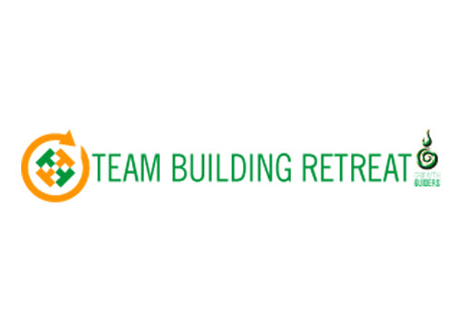

Presenting Partner: Growth Guider

Cost: 7.5 CREDITS

Category: Social Norming

**Program Description:** This two-session intensive program is designed to increase individuals’ knowledge and understanding of leadership and team development in the fraternity environment through a combination of information sessions and active participation in cooperative, challenge activities. Activities are included in the schedule for both sessions, but particularly emphasized on the second day when the group meets outdoors for group problem-solving activities and hiking (one to two flat miles). Challenge activities are chosen to enhance critical thinking skills, creativity, problem-solving ability, and ability to work effectively as a team. Activities included also present opportunities for taking leadership roles, recognizing leadership styles, identifying what works and what doesn’t work in given situations, and applying learning to real life situations.

**Goals:**

* To increase knowledge and understanding of team development.
* To become a more effective team member in working with people of diverse backgrounds, cultures, philosophies, approaches, strengths, and limitations.
* To increase knowledge, understanding, and skills related to leadership.
* To improve skills related to effective problem solving and decision-making. To improve the communication skills of attendees.

**Time:** 2-day retreat (12 hours)

**Intended Audience:** IFC Leadership, Chapter Leadership Teams, Fraternity Educators, Full Chapter Membership

**Partner Bio:**Growth Guiders believes in delivering inspirational programs ranging from small group facilitation to large group keynotes to academic presentations at professional conferences. Growth Guiders takes extra steps to ensure that our learning experiences not only engage students, but lead them on a path to discovery and extend learning into action.

**More Information:** Download a [one-pager](https://www.nicindy.org/wp-content/uploads/2017/08/Team-Building-Retreat_Growth-Guiders.pdf) about this program.

**Booking Information:** [John@growthguiders.com](mailto:John@growthguiders.com)

**Website:**[www.GrowthGuiders.com](http://www.growthguiders.com/)

Thrive: Preparing New Member for Success

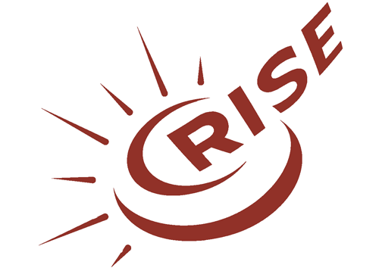

Presenting Partner: RISE Partnerships

PRICE: 7.5 CREDITS

Category: Rites of Passage

**Program Description:** The first few months of a new member’s experience sets the tone for the rest of their lives. If fraternal organizations hope to keep members engaged, retained, satisfied, and prepared to meet expectations, they have to get this process right. Through a series of interactive lessons, Thrive helps leadership teams critique and improve their organization’s new member experience. Along the way, they address underlying challenges in the organization’s culture and learn how to sustain changes for the long-term. This program provides a safe place to restructure questionable activities and gain expert feedback without fear of judgement or consequence.

**Goals:**

As a result of participating, each organization’s leadership team:

* Is better able to articulate the purpose of their new member process.
* Adopts healthier mental models to guide their new member process.
* Can explain the science behind how learning and relationship building truly work.  
  Makes small changes to make existing activities more meaningful, effective, and safe.
* Gains the knowledge, skills, and techniques to implement changes in their organization.

As a result of these outcomes, the organization’s new members will:

* Form stronger connections.
* Learn more about the organization.
* Are better prepared to be involved as leaders.

**Time:** 3 hours

**Intended Audience:** Groups of 3-5 leaders from each organization, including new member education teams and presidents, up to 100 participants.

**Partner Bio:**RISE helps fraternity/sorority leaders do their best work. We provide training, consulting, and curriculum to help students, volunteers, and professionals build their capacity and unravel the most complex problems. Our partners gain the expertise of our staff members, who combine research, evidence, and best practice from a variety of fields to find new and better ways to advance fraternity and sorority communities.

**More Information:** Download a [one-pager](https://www.nicindy.org/wp-content/uploads/2017/08/Thrive_RISE.pdf) about this program.

**Booking Information:** [info@risepartnerships.com](mailto:info@risepartnerships.com); (888) 646-RISE

**Website:**<http://www.risepartnerships.com/thrive/>

The Time is Now: Reclaiming the Value of “Fraternity” Through Social Norming

Presenter: Suzette Walden Cole

Presenting Partner: CAMPUSPEAK

Cost: 7.5 CREDITS

Category: Social Norming

**Program Description:** Negative headlines in the news and social media result in our having to defend “fraternity.” These are the exceptions, not the rule. We must own our fraternal identity and stop letting others define us. Social norming can aid us in combatting messages that lead to a misperception of what truly is normal in our fraternal communities. The time is now to tackle the problem by reclaiming who we are and what we do.

**Facilitator Bio:** Originally from Atlanta, Georgia, Suzette Walden Cole received her Bachelor of Arts from Mercer University in Macon, Georgia and her Master of Education from the University of South Carolina in Columbia, South Carolina. Currently, she is a doctoral candidate in education administration and foundations at Illinois State University, studying the factors that contribute to the development of culture in student groups, student organization conduct and accountability processes and effective strategies for cultivating change within student groups.

**More Information:** Download a [one-pager](https://www.nicindy.org/wp-content/uploads/2017/08/Time-Is-Now_Cole_Campuspeak.pdf) about this program.

**Booking Information:** (844) 745-8570 or [info@campuspeak.com](mailto:info@campuspeak.com)

**Website:** <http://www.campuspeak.com/walden-cole>

Useful and True Ceremonies and Ritualism: An Introduction

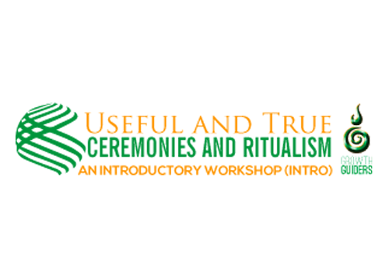

Presenting Partner: Growth Guiders

Cost: 5 CREDITS

Category: Rites of Passage

**Program Description:** Ritual comes in many shapes and will be created and practiced by humans for all of time – as it helps us find meaning and create meaningful connection within our lives. Big or small, private or public, religious or secular – ritual spans from the simplest “Hello” to the highest of sacred practice. Ritual is a critical part of our ever-evolving lives. The symbolic art of initiation – for example, those rituals that provide a clear transition from new member to brother or that mark the change of responsibility and expectations – is seemingly being lost in our conglomerate of worldly traditions. Many of us have not been mentored into the art of creating or leading soulful (big or small) ritual within our communities – this is often something that we leave for gurus, specialist, elders, or just someone other than ourselves. This introduction workshop is meant to help you awaken the ritual focused leader in each man, to ignite a healthy and authentic inner-Ritualist. Attendees will see just how easy it is to bring meaningful rituals into the chapter and community as well as smaller every-day personal practices. We all, as humans, have both the need and capacity for powerful ritual.

**Goals:**

* Increase the ability to recognize and appreciate the value of rituals.
* Foster a deeper understanding of the original and evolving purposes of rituals in our organizations.
* Improve practical skills related to effective and positive engagement of rituals and ceremonies within chapters and the entire community

**Time:** 2.5 hours

**Intended Audience:** IFC Leadership, Chapter Leadership Teams, Fraternity Educators & Ritualists, Chapter Advisors

**Partner Bio:**Growth Guiders believes in delivering inspirational programs ranging from small group facilitation to large group keynotes to academic presentations at professional conferences. Growth Guiders takes extra steps to ensure that our learning experiences not only engage students, but lead them on a path to discovery and extend learning into action.

**More Information:** Download a [one-pager](https://www.nicindy.org/wp-content/uploads/2017/08/Useful-Ceremonies_Growth-Guiders.pdf) about this program.

**Booking Information:** [John@growthguiders.com](mailto:John@growthguiders.com)

**Website:**[www.GrowthGuiders.com](http://www.growthguiders.com/)

Men: Work In Progress – A Conversation on Masculinity

Presenter: James Robilotta

Presenting Partner: CAMPUSPEAK

With this program James is aiming to spark reflection, dialogue, and ultimately a change the thinking and patterns in the men he has to opportunity to work with.

Cost: 7.5 CREDITS

Category: Rights of Passage

**Program Description:** The past couple years have been illuminating and important years for men. For the first time in human history men are uncomfortable, and that is OK; we are a work in progress. By the end of the talk, James will have the audience inspired to: hold each other accountable to being more, be understanding and vulnerable with other men, and be better men.

**Goals:** As a result of attending this program, students will learn:

* how to evaluate how societal norms play a role in men’s ability to connect with each other on a deeper level,
* illustrate examples in their lives where men consciously and subconsciously choose to be cool instead of choosing to be great, and
* how to relate the issues above to men’s role, or lack thereof, in the overall treatment of women.

**Facilitator Bio:** James Robilotta is an author, professional speaker, personal coach, and entrepreneur. He speaks internationally to audiences about authentic leadership and promoting memorability. As a speaker, he is doing the two things he loves the most: causing audiences to think critically about their leadership journeys and making people laugh! His thought-proving talks are infused with self-awareness and comedy stemming from his background as a trained stand-up and improv comedian.

**More Information:** Download a [one-pager](http://nicfraternity.org/wp-content/uploads/2019/02/NIC-James-Robilotta-Masculinity-One-Sheet-Update.pdf) about this program.

**Booking Information:** (844) 745-8570 or [info@campuspeak.com](mailto:info@campuspeak.com)